**Extra Credit**

**User Interface Design**

**Damian DeMarco**

Create the interface and do the coding!

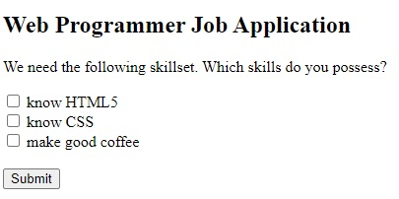

**Grading Rubric**

1. Developed Interface using HTML 33 pts
2. Styled Interface using CSS 33 pts
3. Coded interface using JS 33 pts

100 pts